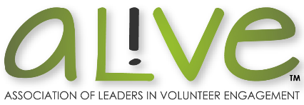
Volunteer Engagement Professional
Career Mapping

Goal | Long-term goal for career aspirations to work towards:
Career Pathways | Potential roles and sequence in which they can be pursued to reach goal:

Development Plan
AREA | ACTION | COMPLETE BY
Assignments and experience I need: | How I will acquire it:
Knowledge/skills I need to move forward: | How I will acquire them:
My strengths that I can build on: | How I will build on them:
Behaviors that might be holding me back: | How I will eliminate or change them:
Attitudes that might be holding me back: | How I will shift them:

